Saint Brigid Catholic Church
3400 Old Alabama Rd.
Johns Creek, GA 30022
Office: 678-393-0060 Fax: 678-393-0071
www.saintbrigid.org
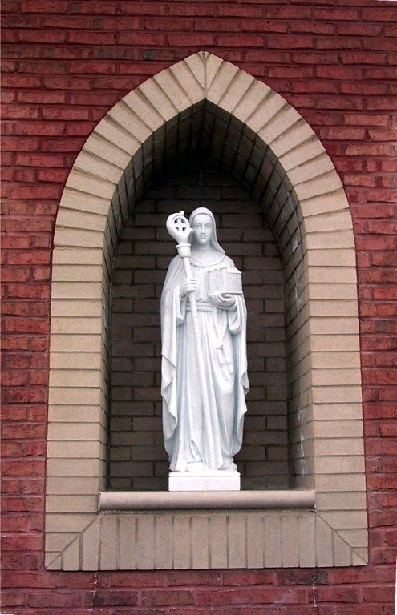
STEWARDSHIP OF TIME & TALENT

As each has received a gift, use it to serve one another, as good stewards of God's varied grace.
1 Peter 4:10

Christ has no body now but yours
No hands, no feet, on earth but yours.
Yours are the eyes through which He looks compassion on this world.
Yours are the feet with which He blesses all the world.
Yours are the hands, yours are the feet.
Yours are the eyes, you are His body.
Christ has no body now on earth but yours
-St. Teresa of Avila
eee

Parish Time & Talent Support

Saint Brigid Catholic Church

Please review the ministry/organization checklist below. If you have a new interest in any ministry listed here, please put a checkmark in the box under your name and next to the ministry. Please use one column for each family member. If you are already a member of any of these ministries, please do not check the box. Thank you!
If all of your ministry selection(s) are to remain unchanged from the prior year, please check here: □

Please Print Clearly:
Last Name: _________________________________________________________________ Date: _______________________
Street Address: ______________________________________________________________ Envelope Number: ____________
City: _________________________________________ State: _____________ Zip: ___________ Phone: ___________________
E-Mail Address: _____________________________________________________________________________________________
New Parishioner? □ Yes □ No * * If ‘No’, please check if New: Address □ Phone □ E-Mail □
 |  | First Name | First Name | First Name | First Name | First Name
INDIVIDUAL E-MAIL ADDRESS
(Adults Only)
MINISTRY/ORGANIZATION |  | New Ministry Interest(s) | New Ministry Interest(s) | New Ministry Interest(s) | New Ministry Interest(s) | New Ministry Interest(s)
ADMINISTRATIVE
●Office Assistance
DAY SCHOOL Assistance
HELPING & HEALING
●Bereavement-Funeral Receptions
●Bereavement & Grief Care
●Comunita Cenacola
HOSPITALITY
●Coffee & Donuts
●Childcare (The Ark)
●Supper Saints
●Sweet & Salty Saints
●Greeter
LITURGY
●Adoration of the Blessed Sacrament
●Altar Flowers
●Altar Linens
●Altar Servers
●Baptismal Bibs
●Children’s Liturgy of the Word (CLOW)
●Decorative Arts
●Extraordinary Ministers of Holy Communion to the Altar
●Extraordinary Ministers of Holy Communion to the Infirm

Page 2 |  | First Name | First Name | First Name | First Name | First Name
MINISTRY/ORGANIZATION |  | New Ministry Interest(s) | New Ministry Interest(s) | New Ministry Interest(s) | New Ministry Interest(s) | New Ministry Interest(s)
LITURGY (CONT.)
●Lectors
●Music: Audio
●Music: Adult Traditional Choir
●Music: Cantors
●Music: Sursum Corda (Chant Schola)
●Music: Children’s Choir
●Music: For His Glory Life Teen Band (4HG)
●Music: Instrumentalists
●Music: Servant Song Ensemble
●Music: Youth Band
●Sacristan
●Ushers
●Wedding Ministry
●White Gloves
OUTREACH MINISTRIES
●The Employment Network (TEN)
●Caring Connection
●Caring Connection-Meals
●Go FISH Outreach
●Habitat for Humanity
●Mustard Seed Communities
●Respect Life
●Saint Vincent de Paul
RELIGIOUS EDUCATION
●Adult Education
●Confirmation
●Edge (6th - 8th Grades)
●Life Teen (9th – 12th Grades)
●PSR (Parish School of Religion)
Catechesis of the Good Shepherd
●PSR (Parish School of Religion)
(Preschool - 5th Grade)
●RCIA Sponsor
●RCIC Sponsor
●Special Needs
●VBS-Vacation Bible School
SOCIAL & FELLOWSHIP
●Athletics: Adults
●Athletics: Children
●Circle of Sisters (Formerly Women’s Guild)
●Knights of Columbus
Page 3 |  | First Name | First Name | First Name | First Name | First Name
MINISTRY/ORGANIZATION |  | New Ministry Interest(s) | New Ministry Interest(s) | New Ministry Interest(s) | New Ministry Interest(s) | New Ministry Interest(s)
SOCIAL & FELLOWSHIP (CONT.)
●Married Couples
●Men of Saint Brigid (MOSB)
●Mom’s Group
●Prime Timers (55+)
●Scouts-Boy
●Scouts-Cub
●Widowed Social Group
●Young Adults
SPIRITUAL
●Christ Renews His Parish (CRHP)
●Couples for Christ/Kids for Christ
●Cursillo – Northside Ultreya
●Elijah Cup-Prayers for Vocations
●Enthronement of the Sacred Heart
●Familia
●Lay Carmelites-Third Order
●Legion of Mary
●Man to Man
●Men’s Bible Study Group
●Natural Family Planning
●Prayer Quilt Ministry
●Rosary: Cenacle
●Rosary: Consecration to our Lady
●Rosary: Daily
●Rosary: Divine Mercy Chaplet
●Rosary: Living
●Rosary: Medugorje
●Rosary Makers
●Sponsor Couples – Marriage Prep
●Traveling Madonna
●Worldwide Marriage Encounter

STEWARDSHIP PRAYER:

Lord Jesus, we believe that you have called us to follow You with our whole hearts in all our words and actions.
Send us your Spirit to give us the power to serve you faithfully.

Lord Jesus, we believe that your disciples are called to proclaim the good news of God’s kingdom.
Send us your Spirit to open our minds and hearts to the liberating power of your word.

Lord Jesus, we believe that stewardship is a way of life.
Send us your Spirit to help us live grateful, generous, and responsible lives.
Amen

Please Fax to: (678)393-0071, mail to 3400 Old Alabama Road, Johns Creek, GA 30022, bring to Mass and give to an usher, drop in collection basket or drop it off in our church office Mon-Fri between 9:00 a.m. to 5:00 p.m. Questions? Please call Teresa at 678-393-0060 ext. 112.
Updated 2/22/2019

