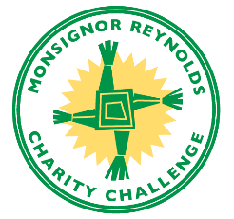

Scoring System Updated for 2020

We start with handicaps provided to us by the individual golfers.
- If they provide a whole number, we record what they give us
- If they provide a USGA index, i.e., a number with a decimal point in it, we convert it to a handicap
- The handicap is based on white tees at Country Club of Roswell using the USGA Handicap Calculator
- https://www.usga.org/course-handicap-calculator.html
- The Handicap Calculator reflects the new USGA handicap rules implemented in 2020.
- For the white tees at CCR, par is 71, course rating is 70.9, and slope is 137
- The calculator adds about 20% to an index given these parameters.

The MRCC event is a team competition (“step aside” scramble format)
- The head pro at CCR converts this information to a team handicap
- He uses the new USGA handicap rules established in 2020 for group handicaps
- For our format, he ranks the players as A, B, C, D based on individual handicaps
- He takes 25% of A’s handicap, 20% of B’s, 15% of C’s, and 10% of D’s to establish a team handicap

